שבוע 3 בפרימרוז

הרצאה:

Overfitting is bad because it follows the dots exactly and doesn’t “learn”

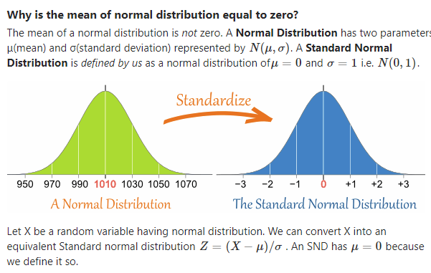

Ex:If the **variance** is 9, the square root of the variance is the **standard deviation** and would be 3

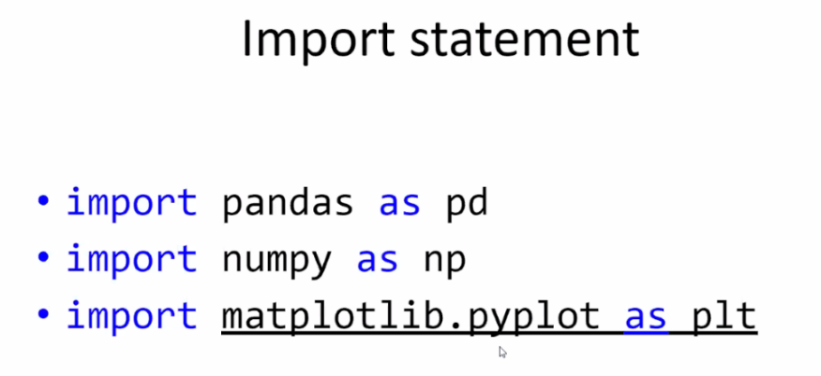תרגול:

OR

from matplotlib import pyplot as plt